AWARDS
WOMEN
UP TO 18, 19-29, 30-39,
4049, 50-59, 60-69, 70+
MEN
UPTO 18, 19-29, 30-39,
4049, 50-59, 60-69, 70+
KIDS
UP TO 5, 6-7, 8-10, 11-12
FREE T-SHIRTS TO FIRST
50 KIDS REGISTERED AND 300 5K & 8K REGISTERED
HEÄLTHQUEST
Prthopedic
OF couNTY
Therapy,
PLLC
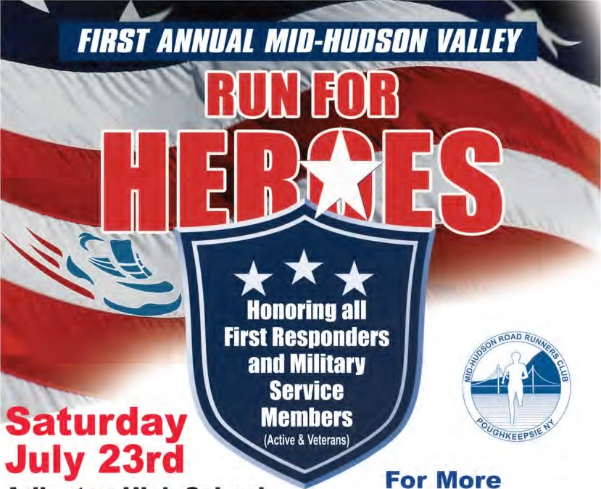For More
Arlington High School Information or

5K Run/Ruck 8:00am start to Register visit
8K Run/Ruck 8:00am start www.mhrrc.org
$20 Pre-Registration $30 Race Day
Free Kid's One Mile (12& under) 7:30am start if Pre-Registered $10 Race Day
All Current First Responders & Contact Email Military Service Members $10 HVrun4heroes@gmail.com If Pre-Registered, $20 Race Day
Meet Co-Race Director and World Marathon Challenge winner and World
Record Holder (7 marathons on 7 continents in 7 days), Marine Corps
Captain Daniel Cartica. This race will also honor the 5 Servicemen who lost their lives in a terrorist attack in Chattanooga, Tennessee on July 16th, 2015.
Check Race: Kids 1 Mile - FREE 5K - $20 8K - S20 Any 1st Responder, Military, Fire or Police Member with Proper ($10 race day) ($30 race day) ($30 race day) ID will be refunded $10 on Race Day for their race. Name Sex
Address
RACE
and
P.O.
Birthdate
City
Zip
Waiver for Race Applications: I know that running a road race is potentially a hazardous activity. I should not enter and run unless I am medically able and properly trained. I agree to abide by any decision of a race official relative to my ability to safely complete the run. I assume all the risks associated with running in this event including, but not limited to: falls, contact with other participants, the effects of weather, including high heat and/or humidity, traffic and the conditions of the road, all such risks being known and appreciated by me. Having read this waiver and knowing these facts and in consideration of your accepting my entry, l, for myself and anyone entitled to act on my behalf, waive and release the Run For Heroes Race, Mid-Hudson Road Runners, Town Of LaGrange, Arlington High School, the Road Runners Club of America, USATF and all sponsors, their representatives and successors from all claims or liabilities of any kind arising out of my participation in this event even though that liability may arise out of negligence or carelessness on the part of persons named in this waiver. Please, No Strollers, Dogs, Roller Blades, or Headphones. Parent's Signature
Signature Date Age—jf under 18 yrs Date

